


MP4050 - 2000LM UNDER BONNET LED INSPECTION LAMP

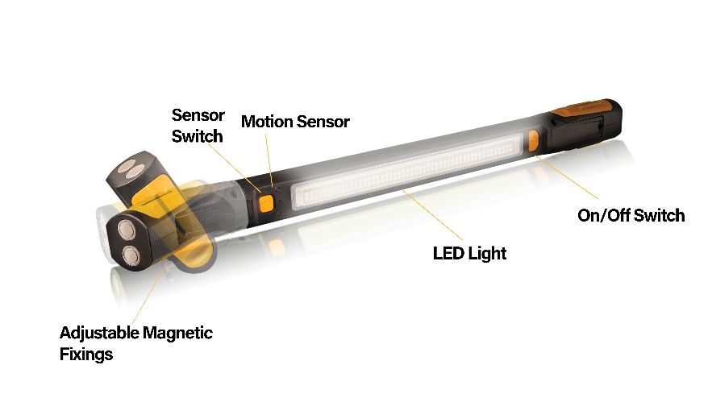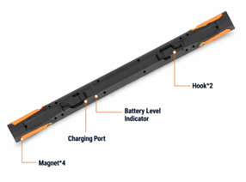

IMPORTANT SAFETY INSTRUCTIONS

- Fully charge the device before first use.
- Do not use the lamp in the immediate vicinity of flammable materials or gases.
- Ensure that the lamp is not covered during use.
- Only ever use this product in conjunction with the accessories supplied.
- This product is not to be used by children unsupervised.
- Refrain from directing the output of the lamp directly into eyes.
- Thoroughly inspect the device and its accessories prior to each use. If any component is damaged, the product should not be used.
- Suitable for use in normal workshop and similar environments where incidental dust ingress and light splashing may occur; the product must not be submerged, or exposed to jets of water.

CHARGING

The device can be charged via USB cable.

- Connect the USB C cable to an AC adaptor (not supplied.)
- Connect AC adaptor to socket outlet and switch on.
- The battery charging status can be confirmed by the illumination of four green LED status lights on the rear face of the torch. Once all four LEDs are permenatly illuminted the charge process is complete.
- Fully charge the device at least once every three months to ensure battery the condition of the battery is maintained.

MANUAL OPERATION

Pressing the on/off or sensor button will activate the lamp. Each press will cycle through the light intensity:

- First press – LED will illuminate at 100% brightness
- Second press – LED will illuminate at 50% brightness
- Third press – LED will illuminate at 25% brightness
- Fourth press - Off

SENSOR OPERATION

Hands free on/off operation will be triggered automatically when the sensor button is pressed. As above, desired brightness can be selected by repeated button presses. Placing your hand within 100mm of the sensor will activate or deactivate the lamp.

MOUNTING OPTIONS

Lamp can be rotated independently to the mounting feet to achieve desired lighting angle.
If using device on a metal surface, magnets fitted into the adjustable feet can be used to secure the lamp.
Fold-out hooks are built into the rear case as an alternative mounting option.

TECHNICAL SPECIFICATIONS

Part No | MP4050
Power | 20W
Lumen | 2000Lm
Battery | 3.7V 4400mAh
Charging period | Approx 3hours
Usage period | 3-3.5h - High  6-7h - Med  10-12h – Low
Sensor range | 100mm
Colour temperature | 6000-7000K
Charging input | 5V DC 1A USB-C
Size | 590 x 40 x 50mm
IP Rating | 20
Weight | 630g

ENVIRONMENTAL PROTECTION

Waste electrical products should not be disposed of with household waste. Please recycle where facilities exist. Check with your local authority or retailer for recycling advice.

DECLARATION OF CONFORMITY

EU / UK DECLARATION OF CONFORMITY - Model: MP4050

This declaration is issued under the sole responsibility of the manufacturer and the objects of this declaration are in conformity with the relevant EU harmonized legislation

EN IEC 55015:2019+A11:2020
EN 61547:2009
EN IEC 61000-3-2:2019+A1:2021
EN 61000-3-3:2013/A2:2021
EN IEC 61547:2023

Technical Manager
Birmingham
April 2026

Manufacturer/Importer:
Maypole Ltd. Maypole Touring Ireland Ltd
162 Clapgate Lane 40 Mespil Road Dublin 4
Woodgate Business Park D04 C2N4
Birmingham B32 3DE Ireland

